
Bahria University, Lahore Campus
Department of Computer Science
Lab Journal 12
(Fall 2024)

Course: | Computer Programming - Lab | Date: _______________
Course Code: | CSL-113 | Max Marks: 10
Faculty’s Name: | Fatima Zulfiqar

Name: __Muneeb Sajid__ Enroll No: _03-134242-076_

Lab Tasks:

Task 1
Implement the given semester project, using the concepts of computer programming in C++ taught in the class.

SOURCE CODE:

#include<iostream>
#include<string>
#include<iomanip>
#include<fstream>
#include <cstdlib> //utility funtions
#include <ctime>

using namespace std;

struct shopping{ // structure = user define data type

char choice;
string name[10];
int price[10];
int quantity[10];
double total[10];
double total_price;
int i;
};
struct order{
string location;
string city;
string homeadress;
};
struct payment
{
int zipcode;
string ph_no;
int balance;
string acc_no;
string cvv;

};
struct user
{
string google_id;
string password;
string username;

};

shopping c; // shopping = structure , c = his object;

string generatePassword(int length) {
const string uppercase = "ABCDEFGHIJKLMNOPQRSTUVWXYZ";
const string lowercase = "abcdefghijklmnopqrstuvwxyz";
const string digits = "0123456789";
const string specialChars = "!@#$%^&*()-_=+[{]}\\|;:'\",<.>/?";
const string allChars = uppercase + lowercase + digits + specialChars;

string password = "";
srand(time(0));

for (int i = 0; i < length; i++) {
int randomIndex = rand() % allChars.length();
password += allChars[randomIndex];
}

return password;
}
void registerUser(user& a) {
cout<<setw(35)<<setfill('-')<<" "<<setfill(' ')<<endl;
int length;

cout << "Welcome to the online shopping store (-_-) " << endl;
cout << "Please enter your email/phone number: ";
cin.ignore();
getline(cin, a.google_id);
cout << "Please enter your username: ";
getline(cin, a.username);

cout << "Please enter the length of your password: ";
cin>>length;
cout<<endl;
a.password=generatePassword(length);

cout<<"Your unique passworsd is="<<a.password<<endl;
cout<<endl;
cout<<"Your account has been succesfully created\n\n"<<endl;

}

void signin(user& a) {
int choice, n;
cout << setw(35) << setfill('-') << " " << setfill(' ') << endl;
string name;
string password;

cout << "Please enter your Google ID for login: ";
cin.ignore();
getline(cin, name);
if (name != a.google_id) {
cout << "You entered the wrong ID! Please try again." << endl;
return ;
}

cout << "Please enter your password: ";
getline(cin, password);
if (password != a.password) {
cout << "You entered the wrong password! Please try again!\n\n" << endl;
cout << "Please select one of the choices:\n";
cout << "1) Forgot password\n";
cout << "2) Return\n";
cout << "Please enter the choice: ";
cin >> choice;

if (choice == 1) {
cout<<endl;
cout << "Your password is: " << a.password << endl;
cout << "1) Do you want to create your own password?\n";
cout << "2) Return\n";
cout << "Please select one of the choices: ";
cin >> n;
cin.ignore(); // Clear buffer
if (n == 1) {
cout << "Please enter your new password: ";
getline(cin, a.password);
system("cls");
} else if (n == 2) {
return;
}
} else if (choice == 2) {
return;
}
} else {
cout << "Successfully logged in!" << endl;
system("cls");
}
}
void profile(user& a)
{
system("cls");
cout<<setw(35)<<setfill('-')<<" "<<setfill(' ')<<endl;

cout<<"your google id is="<<a.google_id<<endl;
cout<<"your user name="<<a.username<<endl;
cout<<endl;

}
void payment_setting(payment& a)
{
cout<<setw(35)<<setfill('-')<<" "<<setfill(' ')<<endl;
int choice;
cout<<"please selected one the following payment option:\n"<<endl;
cout<<"1)JazzCash"<<endl;
cout<<"2)Easy paisa"<<endl;
cout<<"3)Nayapay"<<endl;
cout<<"4)online banking account\n"<<endl;
cout<<"please enter your choice:";
cin>>choice;
cout<<setw(35)<<setfill('-')<<" "<<setfill(' ')<<endl;
switch(choice)
{
case 1:
cout<<"please enter your jazzcash account no: ";
cin.ignore();
getline(cin,a.ph_no);
cout<<"please enter your zip code: ";
cin>>a.zipcode;
cout<<"please enter your balance: ";
cin>>a.balance;
break;
case 2:
cout<<"please enter Easypaisa account no: ";
cin.ignore();
getline(cin,a.ph_no);
cout<<"please enter your zip code: ";
cin>>a.zipcode;
cout<<"please enter your balance: ";
cin>>a.balance;
break;
case 3:
cout<<"please enter nayapay account no: ";
cin.ignore();
getline(cin,a.ph_no);
cout<<"please enter your zip code: ";
cin>>a.zipcode;
cout<<"please enter your balance: ";
cin>>a.balance;
break;
case 4:
cout<<"please enter mobile banking account no with dashes(-) :";
cin.ignore();
getline(cin,a.ph_no);
cout<<"please enter your 3 digit CVV code: ";
cin>>a.cvv;
cout<<"please enter your balance: ";
cin>>a.balance;
break;
default:
cout<<"You entered wrong choice please try again."<<endl;
return;
break;
}

}

void order_tracing(order& f)
{
cout<<setw(35)<<setfill('-')<<" "<<setfill(' ')<<endl;
cout<<"please enter the location: ";
cin.ignore();
getline(cin,f.location);
cout<<"please enter your city: ";
getline(cin,f.city);
cout<<"please enter the homeadress with comma(,): ";
cin.ignore();
getline(cin,f.homeadress);
cout<<"according to your location your order will delivered you in 24 hours"<<endl;
cout<<setw(35)<<setfill('-')<<" "<<setfill(' ')<<endl;
}
void change_password(user a)
{
cout<<setw(35)<<setfill('-')<<" "<<setfill(' ')<<endl;

string password;
cout<<"please enter your previous password:";
cin>>password;
if(password==a.password)
{
cout<<"please enter your password:";
cin>>a.password;
cout<<"Successfully changed password -_- "<<endl;
}
else
cout<<"your enterd the wrong password!! please try again.."<<endl;
}

void shopping_items(shopping& c)
{
cout<<setw(35)<<setfill('-')<<" "<<setfill(' ')<<endl;
c.i=0;
int n;
double groceryPrices[] = {10, 30, 40,50,60};
double clothingPrices[] = {10.0, 20.0,30.0,40.0,50.0};
double bakeryPrices[] = {8, 9,10,11,12};
double mobileAccessoriesPrices[] = {5.0, 7.0,8.0,9.0,10.0};

do {
c.i++;
if (c.i >= 10) {
cout << "You reached your maximum limit!!\n\n" << endl;
return;
}
cout << "Please select one of the following options:\n" << endl;
cout << "1. Grocery items" << endl;
cout << "2. Clothing items" << endl;
cout << "3. Bakery items" << endl;
cout << "4. Mobile accessories" << endl;
cout << "5. Exit\n" << endl;
cout << "Please enter your choice: ";
cin >> c.choice;
switch (c.choice) {
case '1':
cout << "Available grocery items:\n" << endl;
cout << "1. Apples - $10" << endl;
cout << "2. Bananas - $30" << endl;
cout << "3. Oranges - $40" << endl;
cout << "4. Strawberry - $50" << endl;
cout << "5. Blueberry - $60\n" << endl;
cout << "Please enter the choice: ";
cin >> n;
if (n == 1) {
c.price[c.i] = groceryPrices[0];
c.name[c.i] = "Apples";
cout << "Please enter the quantity: ";
cin >> c.quantity[c.i];
c.total[c.i] = c.quantity[c.i] * c.price[c.i];
system("cls");
}
else if (n == 2) {
c.price[c.i] = groceryPrices[1];
c.name[c.i] = "Bananas";
cout << "Please enter the quantity: ";
cin >> c.quantity[c.i];
c.total[c.i] = c.quantity[c.i] * c.price[c.i];
system("cls");
}
else if (n == 3) {
c.price[c.i] = groceryPrices[2];
c.name[c.i] = "Oranges";
cout << "Please enter the quantity: ";
cin >> c.quantity[c.i];
c.total[c.i] = c.quantity[c.i] * c.price[c.i];
system("cls");
}
else if (n == 4) {
c.price[c.i] = groceryPrices[3];
c.name[c.i] = "Strawberry";
cout << "Please enter the quantity: ";
cin >> c.quantity[c.i];
c.total[c.i] = c.quantity[c.i] * c.price[c.i];
system("cls");
}
else if (n == 5) {
c.price[c.i] = groceryPrices[4];
c.name[c.i] = "Blueberry";
cout << "Please enter the quantity: ";
cin >> c.quantity[c.i];
c.total[c.i] = c.quantity[c.i] * c.price[c.i];
system("cls");
}
else {
cout << "You entered the wrong choice!!" << endl;
return;
}
break;

case '2':
cout << "Available clothing items:\n" << endl;
cout << "1. T-Shirt - $10" << endl;
cout << "2. Jeans - $20" << endl;
cout << "3. Swimwear - $30" << endl;
cout << "4. Pajamas - $40" << endl;
cout << "5. Dress - $50" << endl;
cout << "Please enter the choice: ";
cin >> n;
if (n == 1) {
c.price[c.i] = clothingPrices[0];
c.name[c.i] = "T-Shirt";
cout << "Please enter the quantity: ";
cin >> c.quantity[c.i];
c.total[c.i] = c.quantity[c.i] * c.price[c.i];
system("cls");
}
else if (n == 2) {
c.price[c.i] = clothingPrices[1];
c.name[c.i] = "Jeans";
cout << "Please enter the quantity: ";
cin >> c.quantity[c.i];
c.total[c.i] = c.quantity[c.i] * c.price[c.i];
system("cls");
}
else if (n == 3) {
c.price[c.i] = clothingPrices[2];
c.name[c.i] = "Swimwear";
cout << "Please enter the quantity: ";
cin >> c.quantity[c.i];
c.total[c.i] = c.quantity[c.i] * c.price[c.i];
system("cls");
}
else if (n == 4) {
c.price[c.i] = clothingPrices[3];
c.name[c.i] = "Pajamas";
cout << "Please enter the quantity: ";
cin >> c.quantity[c.i];
c.total[c.i] = c.quantity[c.i] * c.price[c.i];
system("cls");
}
else if (n == 5) {
c.price[c.i] = clothingPrices[4];
c.name[c.i] = "Dress";
cout << "Please enter the quantity: ";
cin >> c.quantity[c.i];
c.total[c.i] = c.quantity[c.i] * c.price[c.i];
system("cls");
}
else {
cout << "You entered the wrong choice!!" << endl;
return;
}
break;

case '3':
cout << "Available bakery items:" << endl;
cout << "1. Bread - $8" << endl;
cout << "2. Croissant - $9" << endl;
cout << "3. Pastries - $10" << endl;
cout << "4. Cakes - $11" << endl;
cout << "5. Donuts - $12" << endl;
cout << "Please enter the choice: ";
cin >> n;
if (n == 1) {
c.price[c.i] = bakeryPrices[0];
c.name[c.i] = "Bread";
cout << "Please enter the quantity: ";
cin >> c.quantity[c.i];
c.total[c.i] = c.quantity[c.i] * c.price[c.i];
system("cls");
}
else if (n == 2) {
c.price[c.i] = bakeryPrices[1];
c.name[c.i] = "Croissant";
cout << "Please enter the quantity: ";
cin >> c.quantity[c.i];
c.total[c.i] = c.quantity[c.i] * c.price[c.i];
system("cls");
}
else if (n == 3) {
c.price[c.i] = bakeryPrices[2];
c.name[c.i] = "Pastries";
cout << "Please enter the quantity: ";
cin >> c.quantity[c.i];
c.total[c.i] = c.quantity[c.i] * c.price[c.i];
system("cls");
}
else if (n == 4) {
c.price[c.i] = bakeryPrices[3];
c.name[c.i] = "Cakes";
cout << "Please enter the quantity: ";
cin >> c.quantity[c.i];
c.total[c.i] = c.quantity[c.i] * c.price[c.i];
system("cls");
}
else if (n == 5) {
c.price[c.i] = bakeryPrices[4];
c.name[c.i] = "Donuts";
cout << "Please enter the quantity: ";
cin >> c.quantity[c.i];
c.total[c.i] = c.quantity[c.i] * c.price[c.i];
system("cls");
}
else {
cout << "You entered the wrong choice!!" << endl;
return;
}
break;

case '4':
cout << "Available mobile accessories:" << endl;
cout << "1. Phone case - $5" << endl;
cout << "2. Earphones - $7" << endl;
cout << "3. Power Bank - $8" << endl;
cout << "4. Cases - $9" << endl;
cout << "5. HeadPhones - $10" << endl;
cout << "Please enter the choice: ";
cin >> n;
if (n == 1) {
c.price[c.i] = mobileAccessoriesPrices[0];
c.name[c.i] = "Phone Case";
cout << "Please enter the quantity: ";
cin >> c.quantity[c.i];
c.total[c.i] = c.quantity[c.i] * c.price[c.i];
system("cls");
}
else if (n == 2) {
c.price[c.i] = mobileAccessoriesPrices[1];
c.name[c.i] = "Earphones";
cout << "Please enter the quantity: ";
cin >> c.quantity[c.i];
c.total[c.i] = c.quantity[c.i] * c.price[c.i];
system("cls");
}
else if (n == 3) {
c.price[c.i] = mobileAccessoriesPrices[2];
c.name[c.i] = "Power Bank";
cout << "Please enter the quantity: ";
cin >> c.quantity[c.i];
c.total[c.i] = c.quantity[c.i] * c.price[c.i];
system("cls");

}
else if (n == 4) {
c.price[c.i] = mobileAccessoriesPrices[3];
c.name[c.i] = "Cases";
cout << "Please enter the quantity: ";
cin >> c.quantity[c.i];
c.total[c.i] = c.quantity[c.i] * c.price[c.i];
system("cls");
}
else if (n == 5) {
c.price[c.i] = mobileAccessoriesPrices[4];
c.name[c.i] = "Headphones";
cout << "Please enter the quantity: ";
cin >> c.quantity[c.i];
c.total[c.i] = c.quantity[c.i] * c.price[c.i];
system("cls");
}
else {
cout << "You entered the wrong choice!!" << endl;
return;
}
break;

case '5':
cout << "Exiting the system!" << endl;
break;

default:
cout << "Invalid choice!" << endl;
break;
}
} while (c.choice != '5');

cout<<setw(40)<<setfill('-')<<" "<<setfill(' ')<<endl;
}
double total_calculation(shopping& c)
{
cout<<setw(35)<<setfill('-')<<" "<<setfill(' ')<<endl;
c.total_price = 0;

for (int i = 0; i < 10; i++)
{
c.total_price += c.total[i];
}

return c.total_price;
system("cls");
}
void check_out(shopping &c,payment& a)
{
cout<<setw(35)<<setfill('-')<<" "<<setfill(' ')<<endl;
int order=0;
int choice;
cout<<"Your balance in your account is=$"<<a.balance<<endl;
cout<<"Your total payment is="<<c.total_price;
cout<<"please enter one of the following chocies\n\n"<<endl;
cout<<"1) for check out"<<endl;
cout<<"2) edit your balance"<<endl;
cin>>choice;
if(choice==1)
{
if(c.total_price<a.balance)
{
order=a.balance-c.total_price;
cout<<"Your remaining balance is="<<order<<endl;
cout<<"Sucessfully check out! Thankyou dor chosing us(-_-)"<<endl;
for(int i=0;i<10;i++)
{
c.price[i]=0;
c.price[i]=0;
c.total_price=0;
c.total[i]=0;
}
}
else
{

cout<<"Your balance is less than your payment please add balance!!"<<endl;
return;
}
}
if(choice==2)
{
cout<<"your account no:"<<a.ph_no<<endl;
cout<<"Your balance is $"<<a.balance;
cout<<"please enter your new balance $:";
cin>>a.balance;
cout<<"your Balance is successfully updated"<<endl;
}
else
{cout<<"You entered the wrong choice"<<endl;
return;
}
system("cls");
}
void history_cart(shopping c)
{

ofstream history_file("purchase_history.txt", ios::app);
history_file << "Shopping Cart:" << endl;
for (int j = 0; j<c.i; j++)
{
cout << left << setw(20) << c.name[j]
<< setw(12) << c.quantity[j]
<< setw(15) << fixed << setprecision(2) << c.price[j]
<< setw(15) << fixed << setprecision(2) << c.total[j] << endl;

}

history_file << "Total Price: " << c.total_price << endl;
history_file << "--------------------------------------------" << endl;
history_file.close();
}

void display_cart(shopping c) {
cout << setw(35) << setfill('-') << " " << setfill(' ') << endl;
cout << "Shopping Cart:" << endl;
cout << "--------------------------------------------" << endl;

cout << "Product |" << "quantity | price | total | " << endl;
for (int j = 0; j < c.i; j++) {
cout << left << setw(20) << c.name[j]
<< setw(12) << c.quantity[j]
<< setw(15) << fixed << setprecision(2) << c.price[j]
<< setw(15) << fixed << setprecision(2) << c.total[j] << endl;

}
cout << setw(35) << setfill('-') << " " << setfill(' ') << endl;

}

int main()
{
int i;
int choice;
user b;
payment c;
shopping d;
int e;
order a;

cout << " OOO N N L III N N EEEEE SSS H H OOO PPPP PPPP III N N GGG SSS TTTTT OOO RRRR EEEEE" << endl;
cout << "O O NN N L I NN N E S H H O O P P P P I NN N G S T O O R R E " << endl;
cout << "O O N N N L I N N N EEEE SSS HHHHH O O PPPP PPPP I N N N G GG SSS T O O RRRR EEEE" << endl;
cout << "O O N NN L I N NN E S H H O O P P I N NN G G S T O O R R E " << endl;
cout << " OOO N N LLLLL III N N EEEEE SSS H H OOO P P III N N GGG SSS T OOO R R EEEEE" << endl;

do{
cout<<"1.register "<<endl;
cout<<"2.sign in "<<endl;
cout<<"3.profile "<<endl;
cout<<"4.payment setting"<<endl;
cout<<"5.order tracing"<<endl;
cout<<"6.online shopping"<<endl;
cout<<"7.change password"<<endl;
cout<<"8.Total price"<<endl;
cout<<"9.Check out"<<endl;
cout<<"10.Cart"<<endl;
cout<<"11.History of cart"<<endl;
cout<<"12.exit"<<endl;
cout<<"please enter the code above(1~11):";

cin>>choice;
system("cls");
if(choice==1)
{
system("cls");
registerUser(b);

}
else if(choice==2)
{
system("cls");
signin(b);

}
else if(choice==3)
{
system("cls");
profile(b);

}
else if(choice==4)
{
system("cls");
payment_setting(c);
system("cls");

}
else if(choice==5)

{
system("cls");
order_tracing(a);

}
else if(choice==6)
{
system("cls");
shopping_items(d);

}
else if(choice==7)
{
system("cls");
change_password(b);

}
else if(choice==8)
{
system("cls");
e=total_calculation(d);

cout<<"The total price=$"<<e<<endl;

}
else if(choice==9)
{
system("cls");
check_out(d,c);

}
else if(choice==10)
{
system("cls");
display_cart(d);

}
else if(choice==11)
{
system("cls");
cout<<setw(35)<<setfill('-')<<" "<<setfill(' ')<<endl;
history_cart(d);

}
else if(choice==12)
{
cout<<"Exiting the system"<<endl;

}
else
cout<<"please enter choices between(1~12)"<<endl;
}while(choice!=12);
system("pause");
return 0;

}//system cls;

OUTPUT :
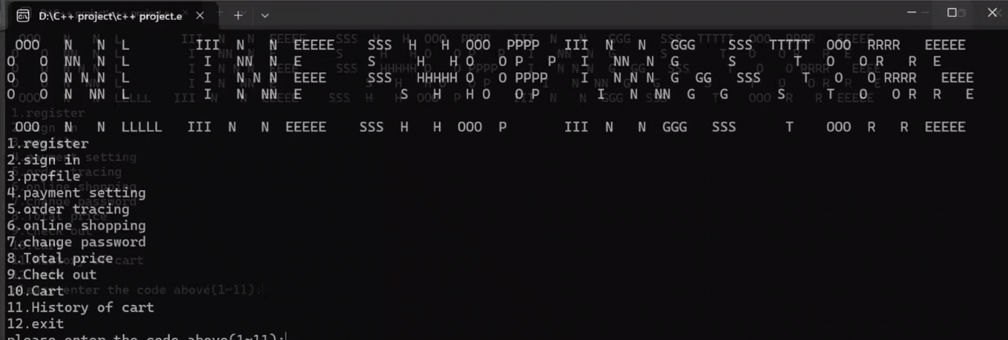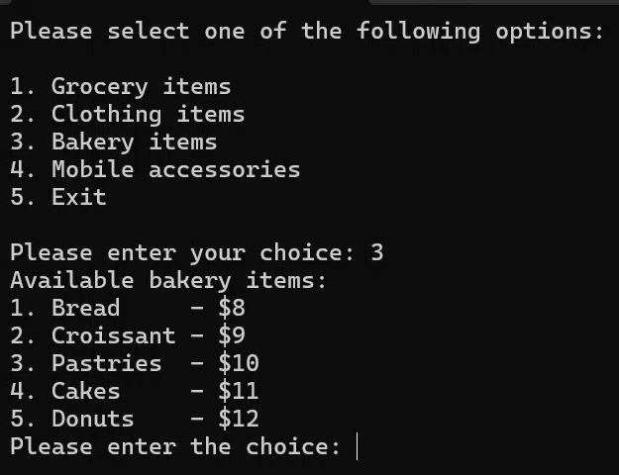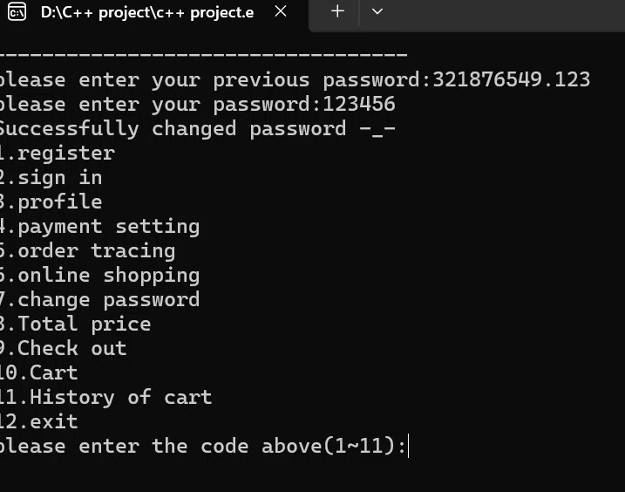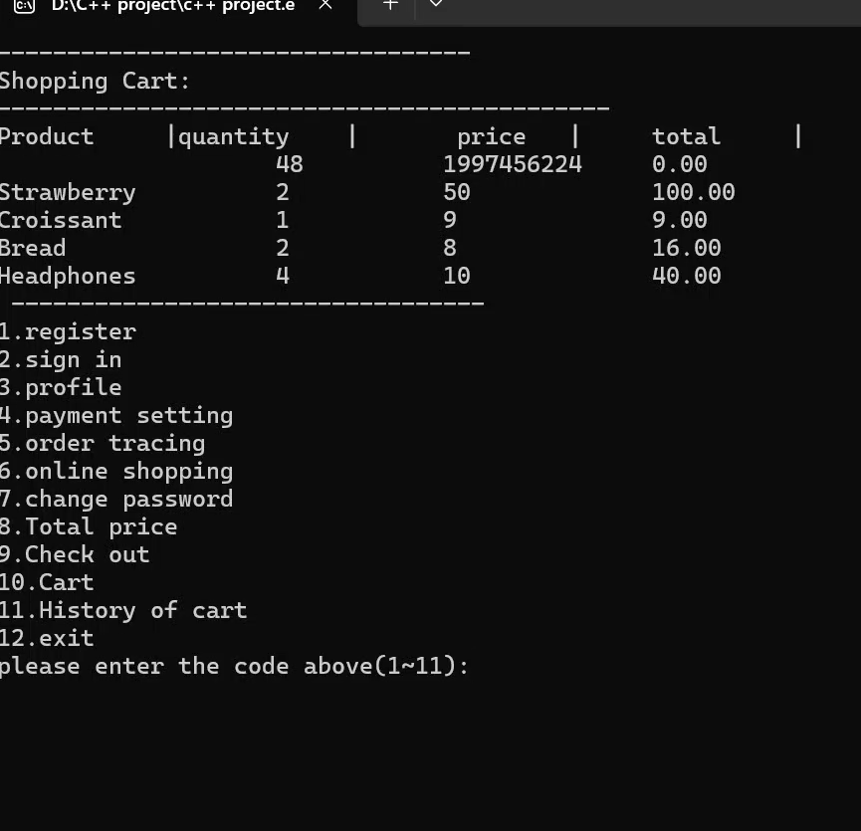
Lab Grading Sheet :
Task | Max Marks | Obtained Marks | Comments(if any)
1. | 10
Total | 10 |  | Signature

Note: Attempt all tasks and get them checked by your Lab Instructor. Attach a screenshot of output for each task.

